

C & C Hydraulics

T: 01535 617880 E:sales@cchydraulics.co.uk

***DC Power Unit Owners Manual***

***Page*** ***Contents***

1. Safety
2. Identification

3 Warranty

4 Hydraulic Fluid

5 Maintenance

6 Installation

7 Initial Startup Procedure

8 Single Acting Power unit

(YBZ6-F2.7B1A2/WUUAN1/RC)

9 Troubleshooting

***Introduction:***

Thank you for choosing a Deli Hydraulics product. Please read this document in its entirety before operating the equipment. Insure the operator is adhering to the safety precautions at all times.

Failure to follow the safety precautions could result in severe injury or death.

Always maintain your power source & power unit to insure trouble fee operation.

Please consult the factory or a qualified hydraulic technician before attempting to repair hydraulic equipment. The disassembly of a power unit still under warranty will void the warranty. If you need assistance please consult the factory.

1. Safety

This information is intended for use by a service technician who is familiar with hydraulic components & understands the required safety precautions. Please consult factory for any questions that may not be answered in this document.

WARNING:

IF THE PRESSURE RELIEF SETTINGS ARE TAMPERED WITH THE WARRANTY IS VOID

If you perform service on your own Deli Hydraulics product you must assume responsibility for personal injury or property damage that may result.

Please read full equipment manual before attempting to operate equipment.



* + Tampering with relief valve
    - Tampering or adjusting the relief valve will void warranty, and could cause catastrophic failure which could result in equipment damage, severe injury or even death. ***Adjusting the relief valve will not increase flow!***
  + Hydraulic Fittings & Hoses
    - * Always insure hydraulic lines are not routed around or across sharp edges that may cause chafing and damage to hose.
      * Never crack or loosen a hydraulic connection under pressure. Doing so can result in a hydraulic injection. For more information on Hydraulic
      * Always follow the manufactures torque specifications for fittings and hoses.

***Warning:*** Loosening hydraulic lines under pressure can result in catastrophic failure which could result in equipment damage, severe injury or even death.

***Read OEM manual before attempting to operating power unit***

For more information on hydraulic safety visit

[www.fluidpowersafety.com](http://www.fluidpowersafety.com)

***3. Warranty:***

Wuxi Deli Hydraulics Co., Ltd. warrants all Deli’s power units to be free from defects in material and workmanship from the date of purchase throughout the duration of the warranty period. All Deli’s power units for overseas’ market are warranted for the period of 13 months from the on board date.

During the warranty period, Deli will, at its option, replace a defective product with a new or refurbished product, or ask the customer to repair the defective product with a new or rebuilt part sent by Deli, at no charge except as stated below. The defective parts or products that are replaced become the property of Deli.

**For Information Contact:**

Wuxi Deli Hydraulics Co., Ltd **No 225 Xitai Road,(Meicun) New District Wuxi Jiangsu China**

**tel:86-510-88551806  
fax:86-510-88551809**

***2. Unit Identification:***

Before contacting factory for assistance please insure you have the model code & serial number available.

* *Fill in the fields below upon receiving or installing the power unit.*
* *Keep this information on or near the equipment, making it readily available when needed.*

|  |
| --- |
| Model Code: |
| Serial Number: |
| Pressure Setting: |

* The Model Code is located on the identification label that is affixed to the reservoir.
* The Serial Number is located the end-head/ manifold block (serial number may not be visible after installation)
* The pressure setting is located on the identification label that is affixed the reservoir.

If you are having trouble identifying the unit in question please consult factory for assistance. The model code and serial number are extremely important; they will help us help you answer any questions you might have in a timely manner.

***4. Hydraulic Fluid:***

Hydraulic fluid selection & regular fluid inspection is very important to increase the life of your hydraulic system. The function of Hydraulic fluid is to transfer power from the gear pump to the actuator, weather it is a hydraulic motor o Cylinder.

Selecting the proper fluid viscosity is very important. Selecting a fluid that is to thin may not lubricate the gear pump properly; causing premature pump failure. Also selecting a fluid that is to thick will induce load & cause power loss or cavitation causing gear pump failure.

ISO viscosity grades 22 to 46 are recommended. Anti wear, antifoaming & rust inhibitor additives are recommended.

For colder climates ATF can be used

In extreme cases Mil-5606 fluid can be used

Do not use synthetic, biodegradable or water base hydraulic fluids. In most cases these fluids are not compatible with Buna O-rings. Please check fluid compatibility before use.

Tractor hydraulic fluid is not recommended. Most tractor hydraulic fluid has to high of a viscosity & may not be compatible with Buna O-rings.

***Recommended Fluid Viscosity Specifications:***

*ISO Viscosity Grades 22-46*

*cSt @ 40°C 22-46*

*cSt @ 100°C 4-8*

***Recommended Fluid Maintenance:***

* + Change hydraulic fluid after initial 100 hours of operation
  + Change hydraulic fluid every 3000 hours or 2 years there after
  + Check hydraulic fluid level regularly before operation

***5. Maintenance:***

* + Change hydraulic fluid after initial 100 hours of operation
  + Change hydraulic fluid every 3000 hours or 2 years there after
  + Check hydraulic fluid level regularly before operation
  + Recommended fluids
  + Check electrical connections regularly
    - Corrosion on all connectors
    - Battery cables
  + Load test battery often before use
  + Cleaning
    - Never pressure wash or hose down the power unit. The DC motor is not sealed extended exposure to moisture will cause premature motor failure.
    - Spray light amounts of cleaner/degreaser on unit and dry with compressed air and/or rag.
    - Cleaning reservoir breather cap

*Remove red cap from breather cap and clean filter element with dishwashing soap & water. Make sure the filter element is completely dry before installing back in the breather cap*

***6. Installation:***

1. Location
   * Power unit should be mounted either in an enclosure or a location preventing the unit from being exposed moisture and weather.
   * Units with Poly reservoirs should never be mounted in a location where the reservoir is exposed to direct sunlight.-
   * Mount unit as close to the battery as possible.
2. ***Mounting***

* All Deli YBZ6 series DC power units utilize the same bolt pattern-M10-6H x 15mm deep, the holes are 82mm apart

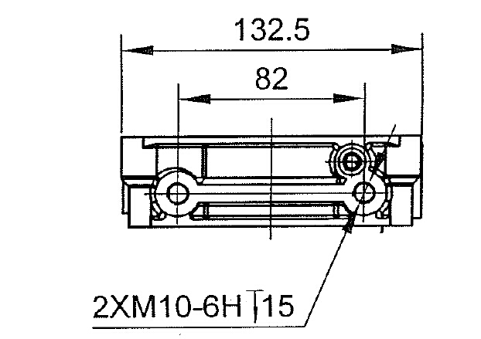

1. ***Hydraulic Hoses & Connections***
   * ***Never Crack Hydraulic Fitting When Pressurizes*** Cracking hydraulic fittings or hoses under pressure can result in severe injury.
   * ***If Hydraulic Injection Occurs Seek Medical Attention Immediately*** Hydraulic injection may initially resemble a bite or sting
   * ***Never route Hydraulic Hoses*** around or across sharp edges that may cause chafing and damage to rubber insulation
   * ***Never route Hydraulic Hoses*** near moving parts that may pinch or chafe rubber insulation
   * ***Check Hydraulic Hoses Regularly***

Check for cracks or wear on hydraulic hoses. If you can see steel braiding your hoses need to be replaced.

* ***Always Use Hoses and Fittings Intended for Use on Hydraulic Equipment*** Consult fitting specifications and relief valve setting when selecting Hoses and Fittings.
* All ports are G1/4’’ O-ring boss.
* Lubricate all O-rings before installation
* For an additional manifold mounted to unit consult equipment mfg. for specifications
* For adjustable o-ring fittings back nut off a few turns, insuring the o-ring id is not on fittings threads
* If thread sealant is required use liquid thread sealant. If Teflon tape must be used; 1.5 to 2 wraps is plenty. Insure no tape is over the end of the fitting.

1. **Electrical**

* ***Reference the Battery Cable Selection Chart*** to ensure the proper gage battery cable has been selected for power unit location
* ***Never route electrical*** around or across sharp edges that may cause chafing and damage to cable/wire insulation
* ***Never route electrical*** near moving parts that may chafe or pinch cable/wire
* **Electrical Connections**
* When tightening studded electrical connections the nut only needs to be tight enough to collapse the spring lock washer.
* Ensure all spade connections are secure.
* Check electrical connect regularly for corrosion and tightness.
* **Negative Cable from Battery/Ground**
  + Two terminal DC motors have an isolated ground – The Battery cable must be connected to the Ground stud on the DC motor. (the stud with the cable connected to the start solenoid is the positive stud. The negative wire will have a ground wire connected to the base of the start solenoid)

1. ***Filling reservoir***

* Notice two lined on dipstick of Breather cap
  + The top line indicates maximum fluid level
  + The bottom line indicated the minimum fluid level
    - Fill reservoir to the top line on dipstick of breather during initial start up.
    - Fill reservoir to fill line on dipstick after air has been cycled out of the system

***7. Startup Procedure***

* Double check all electrical & hydraulic connections
* Run power unit momentarily ensuring the pump is priming & the load has started to move.
  + - 1. If load doesn’t move after a few tries reference troubleshooting section *– pump not priming*
* Check voltage drop
  + - 1. Connect a volt meter to the power unit not the battery.
      2. For the 12 V DC power units, run power unit momentarily the voltage should not drop below 11.4 volts with a full charged battery.
      3. For the 24VDC power units, run power unit momentarily the voltage should not drop below 22.8 volts with a full charged battery.
      4. With a fully charged battery the maximum voltage drop is 5%
* Purging air from hydraulic system
  + - 1. Start by cycling the cylinder about 25% of the full stroke of the cylinder.
      2. During and after each stroke keep an eye on the fluid level and condition of the fluid in the reservoir.
      3. The fluid level should never exceed 2’’ from the bottom of the reservoir
      4. Check for excessive aeration of the hydraulic fluid. Increase time between cycles if fluid aeration is present.
* If excessive aeration persists stop cycling the cylinder, let the unit rest until the air has dissipated from the reservoir then continue cycling.
* To reduce the amount of air being reintroducing to the hydraulic system
  + - 1. Let power unit rest between cycles,
      2. With each cycle of the cylinder increase the stroke by 25% or less
      3. You may need to add fluid to the reservoir after each cycle.
      4. Only add fluid when cylinder is retracted
      5. For intermittent duty applications the reservoir volume is sized off the rod volume of the cylinder, plus a percentage to prevent pump cavitation. More down time between cycles will be required when bleeding the system
      6. Always check battery voltage before

* + 1. Double check hydraulic system
       1. Check all fitting and hoses for leaks
       2. If you think you may have one wipe the fluid off & cycle the unit a few times ensuring the fluid is not some residual fluid residue from installation
       3. Check all electrical connections making sure they are tight
       4. Check fluid level
       5. Check charging system ensuring the battery is able to receive a charge

Notes:____________________________________________________________________________________________________________________________________________________________________________________________________________________________________________________________________________________________________________________________________________________________________________________________________________________________________________________________________________________________________________________________________________________________________________________________________________________________________________________________________________________________________________________________________________________________________________________________________________________________________________________________________________________________________________________________________________________________________________________________________________________________________________________________________________________________________

***8. Single Acting Power unit***

***For example: YBZ6-F2.7B1A2/WUUAN1/RC***

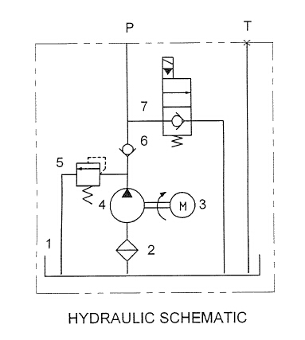 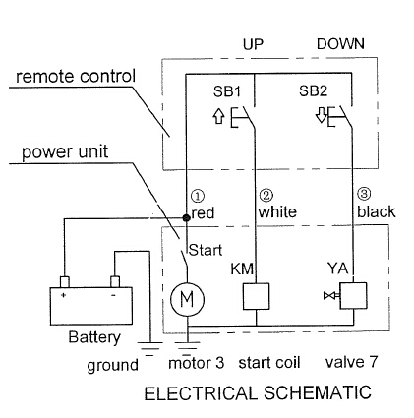

***Outline drawing:***

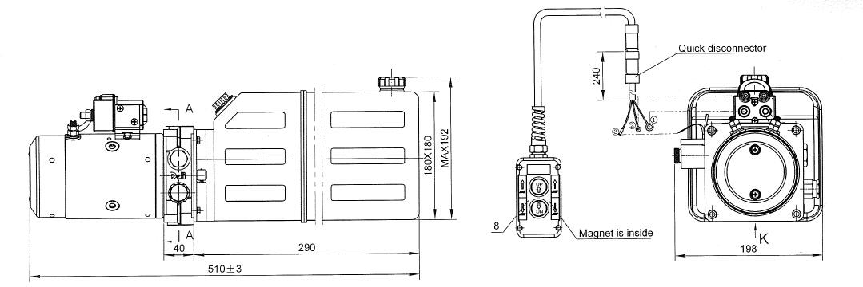

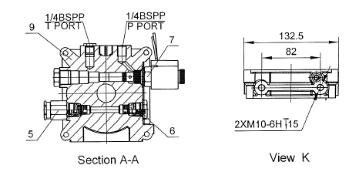

***Description:***

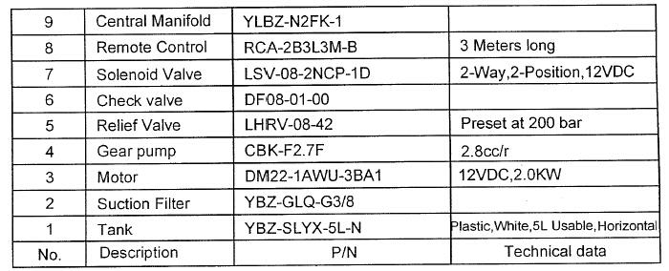

***9. Troubleshooting***

Safety

This information is intended for use by a service technician who is familiar with hydraulic components & understands the required safety precautions. Please consult factory for any questions that may not be answered in this document.

WARNING:

IF THE PRESSURE RELIEF SETTINGS ARE TAMPERED WITH THE WARRANTY IS VOID

If you perform service on your own Deli Hydraulics product you must assume responsibility for personal injury or property damage that may result.

Please read full equipment manual before attempting to troubleshoot and make repairs.



* + Tampering with relief valve
    - Tampering or adjusting the relief valve will void warranty, and could cause catastrophic failure which could result in equipment damage, severe injury or even death. ***Adjusting the relief valve will not increase flow!***
  + Hydraulic Fittings & Hoses
    - * Always insure hydraulic lines are not routed around or across sharp edges that may cause chafing and damage to hose.
      * Never crack or loosen a hydraulic connection under pressure. Doing so can result in a hydraulic injection. For more information on Hydraulic
      * Always follow the manufactures torque specifications for fittings and hoses.

|  |  |  |  |
| --- | --- | --- | --- |
| ***Symptoms*** | ***Possible Cause*** | ***Correction*** | ***Special Notes*** |
| System Inoperative | Dead or Low Battery | Load test battery | Charge or replace battery |
| Poor Ground | Ground battery directly to DC motor | Use jumper cables to jump ground only |
| Dirty Contacts in Hand Control | Clean contact in hand control with eraser | Cleaning contacts with abrasive will cause frequent failure |
| Corrosion on Battery Terminals | Inspect battery cables & clean battery terminals | Use of dielectric grease will prevent corrosion buildup |
| Start Solenoid Failure | Jump Start Solenoid | Replace Solenoid |
| Rust in DC Motor | Bypass Start Solenoid | If motor doesn't run after bypassing start solenoid, remove rear cover of motor for quick inspection. |
|  |  |  |  |
|  |  |  |  |
| ***Symptoms*** | ***Possible Cause*** | ***Correction*** | ***Special Notes*** |
| Motor Runs Load Not or Cylinder not Extending | Low Battery/ Poor Ground | Load test battery | Charge or replace battery |
| **Bad diode in hand control | Remove coil from directional valve & operate unit. Only 1 valve coil should operate at a time. | Replace diodes inside hand control if 2 coils are operating when pressing up or down button. |
| Dirty Contacts in Hand Control | Clean contact in hand control with eraser | Cleaning contacts with abrasive will cause frequent failure |
| **Directional Valve Issue | Check for bent valve stem | Replace valve if stem is bent |
| Ensure coil is energizing | Double check you are getting power to coil before replacing |
| Remove valve and inspect o-rings | Replace o-rings if damaged |
| Check cross drilled holes between o-rings of valve for debris | Replace valve if spool is not shifting *(for most directional valves the spool will cover half of the cross drilled holes when valve is at its at rest or activated positions)* |
| Ensure valve is shifting *(use dipstick push on valve spool to shift valve. Look through cross drilled holes between o-rings insuring valve is shifting)* |
| Pump Not Priming | *Remove check valve & activate motor momentarily to prime. | Replace gear pump if problem is not solved |
| **Remove check valve plug & activate motor momentarily to prime |
| Relief Valve | If relief valve is bypassing check pressure gage to insure valve is set at proper setting as marked on power unit | Double check with equipment manufacturer insuring the manufacturer did not adjust pressure setting at factory. |
| Cylinder | **Check to see if fluid is passing through the rod seals to tank | Rebuild or replace the cylinder if fluid is passing through the cylinder without moving the rod |
| * Check to see if fluid is coming out vent on rod end of cylinder when fully retracted |
|  |  |  |  |
|  |  |  |  |
| ***Symptoms*** | ***Possible Cause*** | ***Correction*** | ***Special Notes*** |
| (*Single Acting) Cylinder Not Retracting | Dead or Low Battery | Load test battery | Charge or replace battery |
| Poor Ground | Ground battery directly to DC motor | Use jumper cables to jump ground only |
| Coil on Solenoid Valve not Activating | Insure power is getting to coil, check all electrical connections and check for magnetism | Replace coil if you are getting power to the coil but it is not energizing. |
| Check ground wire or valve stem. For loose connections or corrosion. *(If coil is single wire lead, check the contacting point where solenoid rests on valve stem for corrosion)* |
| Loose wire in quick connector or control box |
| Clean contact in hand control with eraser |
| Bent stem on solenoid valve | Inspect stem on solenoid valve **(*DO NOT REMOVE VALVE FOR INSPECTION IF SYSTEM IS UNDER PRESSURE)*** | Replace valve if stem is bent |
| Debris in screen of load holding valve | Remove load holding valve. Inspect screen & valve for debris. (***DO NOT REMOVE VALVE FOR INSPECTION IF SYSTEM IS UNDER PRESSURE)*** | Load holding valve is below fluid level. Removing this valve will partially drain reservoir. |
| Debris in flow control valve | Remove flow control valve & inspect valve for debris. | Top of valve is threaded, use 1/4-20 bolt to remove flow control valve. |
| Cylinder issue | Fluid coming out vent on rod end of cylinder | Replace cylinder |
| Check cylinder alignment | Contact equipment manufacturer if this is an issue |
| Packing in cylinder may have failed | Contact equipment manufacturer for replacement cylinder |
|  |  |  |  |
|  |  |  |  |
| ***Symptoms*** | ***Possible Cause*** | ***Correction*** | ***Special Notes*** |
| Reservoir Overflows When Lowering | Low fluid level | Add fluid to reservoir when cylinder is fully retracted | Before running power unit insure all air bubbles have dissipated to prevent further aeration of fluid |
| Loose Inlet | Remove reservoir & tighten or replace inlet tube on pump |
| Reservoir too small for hydraulic system | Consult equipment manufacturer for correct reservoir size |
|  |  |  |  |
| ***Symptoms*** | ***Possible Cause*** | ***Correction*** | ***Special Notes*** |
| Unit Struggles to Lift Load | Dead or Low Battery | Load test battery | Charge or replace battery |
| Poor Ground | Ground battery directly to DC motor | Use jumper cables to jump ground only |
| Directional valve not completely shifting** | Check for bent valve stem | Replace valve if stem is bent |
| Check cross drilled holes between o-rings of valve for debris | Replace valve if spool is not shifting *(for most directional valves the spool will cover half of the cross drilled holes when valve is at its at rest or activated positions)* |
| Ensure valve is shifting *(use dipstick push on valve spool to shift valve. Look through cross drilled holes between o-rings insuring valve is shifting)* |
| Debris in screen of load holding valve | Remove load holding valve. Inspect screen & valve for debris. (***DO NOT REMOVE VALVE FOR INSPECTION IF SYSTEM IS UNDER PRESSURE)*** | Use dipstick on power unit to manually shift the valve. This is accomplished by inserting the dipstick in the nose of the valve and applying pressure. Replace valve if it doesn't shift. |
| Rust in Motor | Bypass Start Solenoid | If motor doesn't run at a higher RPM after bypassing start solenoid, remove rear cover of motor for quick inspection. |
| Worn seals in cylinder | Packing on piston of cylinder could be bad and be wedged against bore of cylinder. | Have cylinder tested by certified technician |